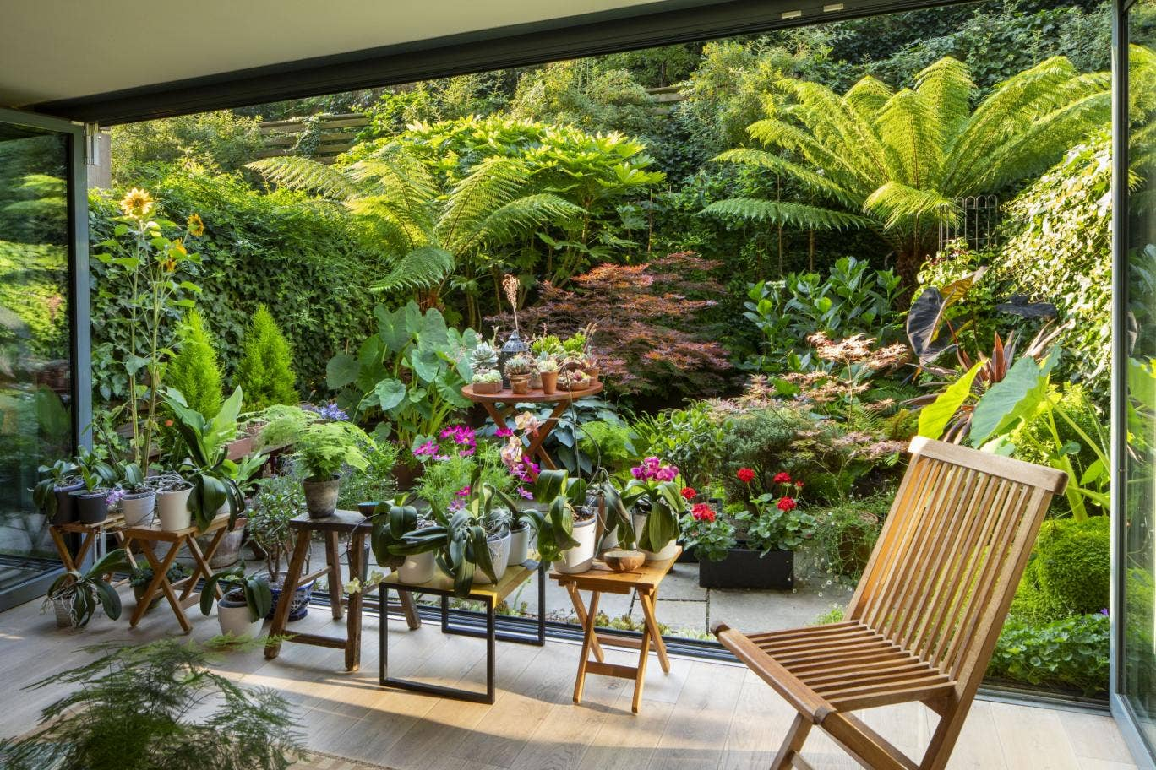
Patio Jungle
Juan Carlos Cure DBG talk
4th February 2020

Architectural Plants
Dicksonia Antarctica (Tree Ferns) (2)
Japanese maple – Acer Palmatum Bloodgood
Fatsia Japonica (Japanese Aralia)

Plants in Pots
1 Hydrangea macrophylla (white)
3 Hostas (2 Halcyon and 1 varigated white/green)
1 Arum Lily
1 Fern
1 Hebe Topiaria
Climbers
1 Group 2 (Large Spring flowering)
2 Group 3 Clematis Viticella (Princess Kate and a pink flowering)
Small leaved Ivy (Climbers on wall and Fences)
Common Jasmine (Climber on Fence)

Plants on Wall
Bluebell (Campanula)
Erigeron
On the gravel area below glass door
Sempervivums
Bluebells
Linaria

On the paved area
Soleirolia soleirolii (Mind your Own Business)
Erigeron

Annual Plant
Cosmos

1 Cotinus (purple)
2 Lemon Cypress
1 Euphorbia Characias Wulfenii
1 Colocasia Esculenta Green
1 Colocasia Esculenta Black Magic
1 Asparagus “Fern”
1 Himalayan Banana tree
2 Crassulas (1 Jade, Riple Jade)
1 Osteospermum (South African daisy – purple dark and light)
1 Geranium
1 Agapanthus
1 Lavander
4 Erigeron
1 Bluebell
Multiple sedums (Echeverrias, Aloes and
Semperviviums (houseleeks))

Plants growing on the ground
Japanese Spindles (3)
Ferns (2 hart’s tongue, Japanese painted, Ostrich Ferns,
Autumn Fern, common fern)
Hostas (3)
Aurum Lily
Brunnera
Varigated Ivy (white/green)
Vinca Minor

